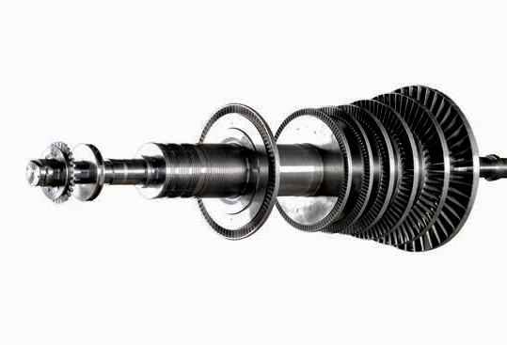

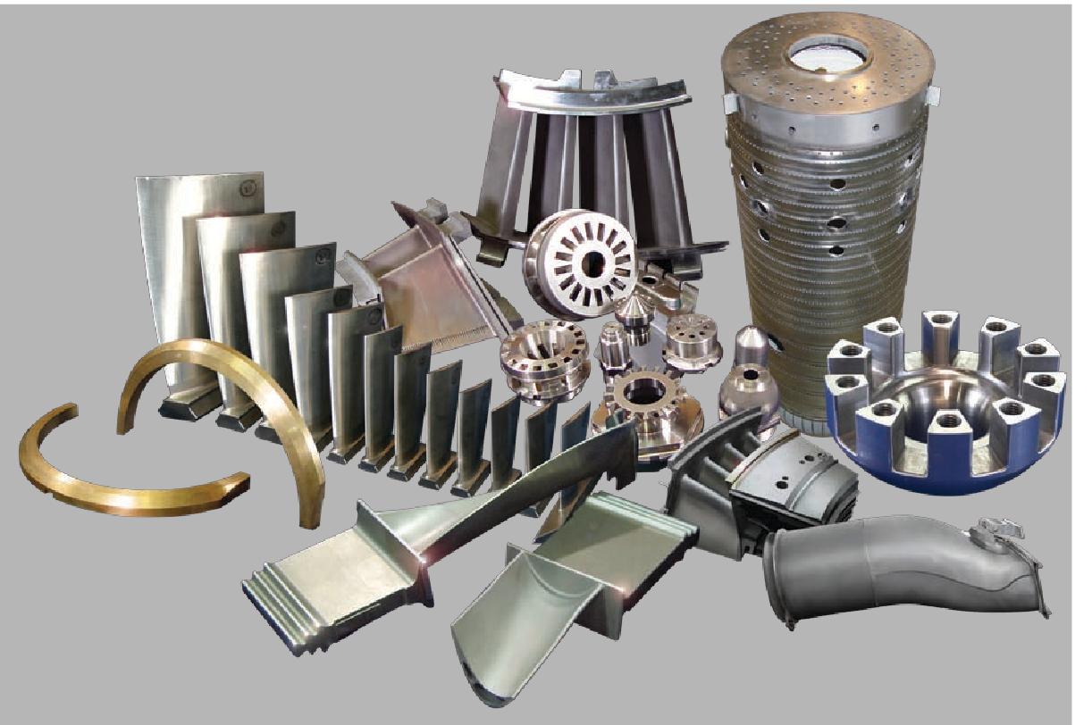

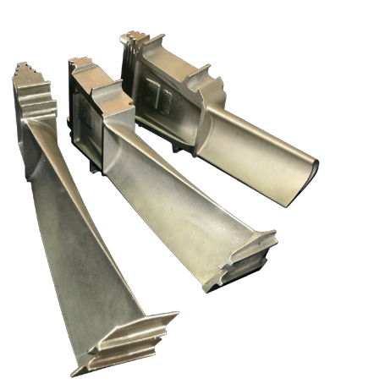

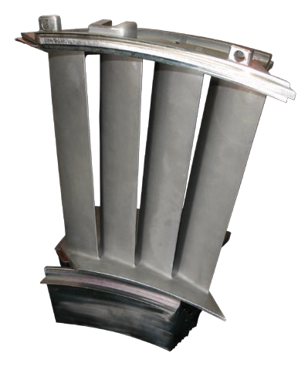

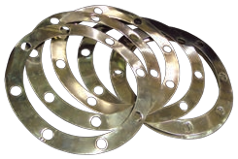Gaskets

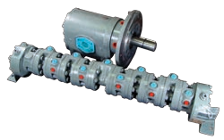 Fuel Pumps & Flow Dividers

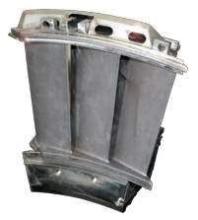

Nozzles

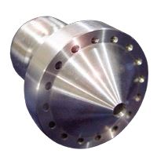

Fuel Nozzle Accessories

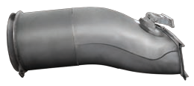

Transition Piece

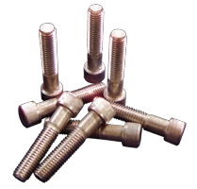

Hardware

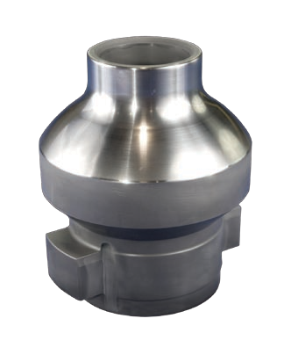

Bypass valve

Hydrogen seal ring

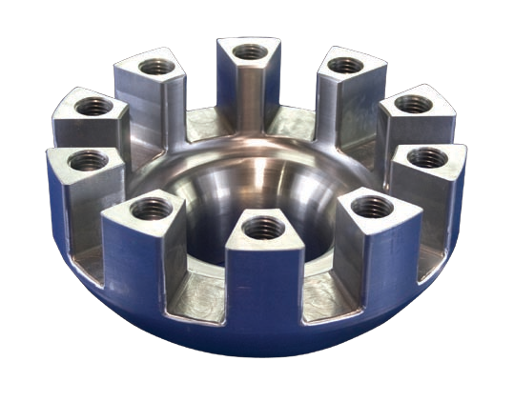

Valve cap

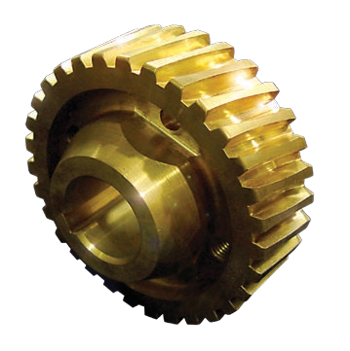

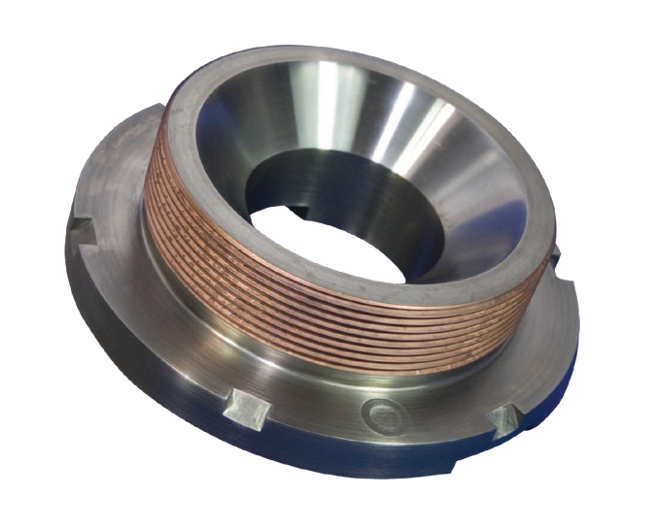Worm Gear

Cap

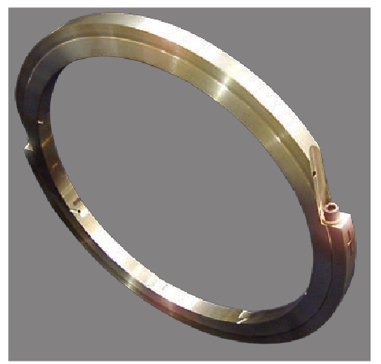

Pump seal ring

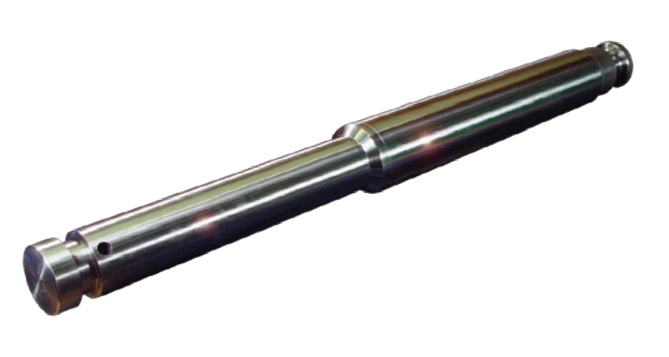

Stem

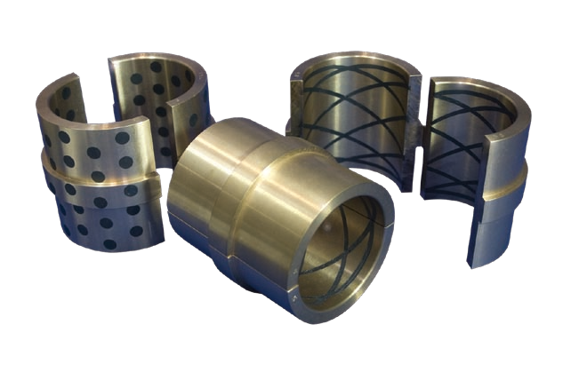

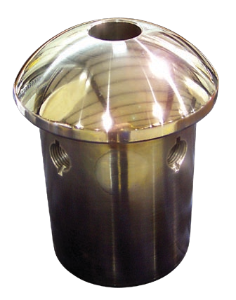Bronze-Graphite Bushing

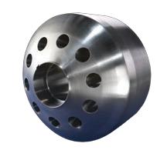Control Valve

Valve Seat



Packing Ring

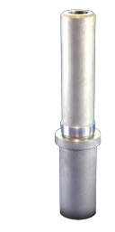

Bushing

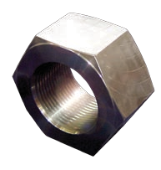

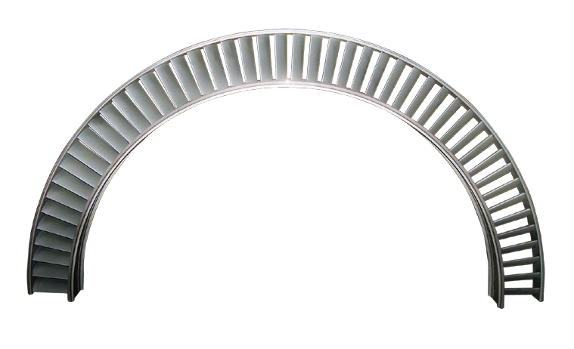Hex nuts

Diaphragm

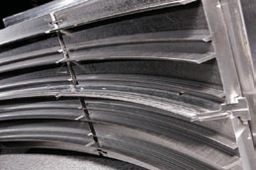

Seals

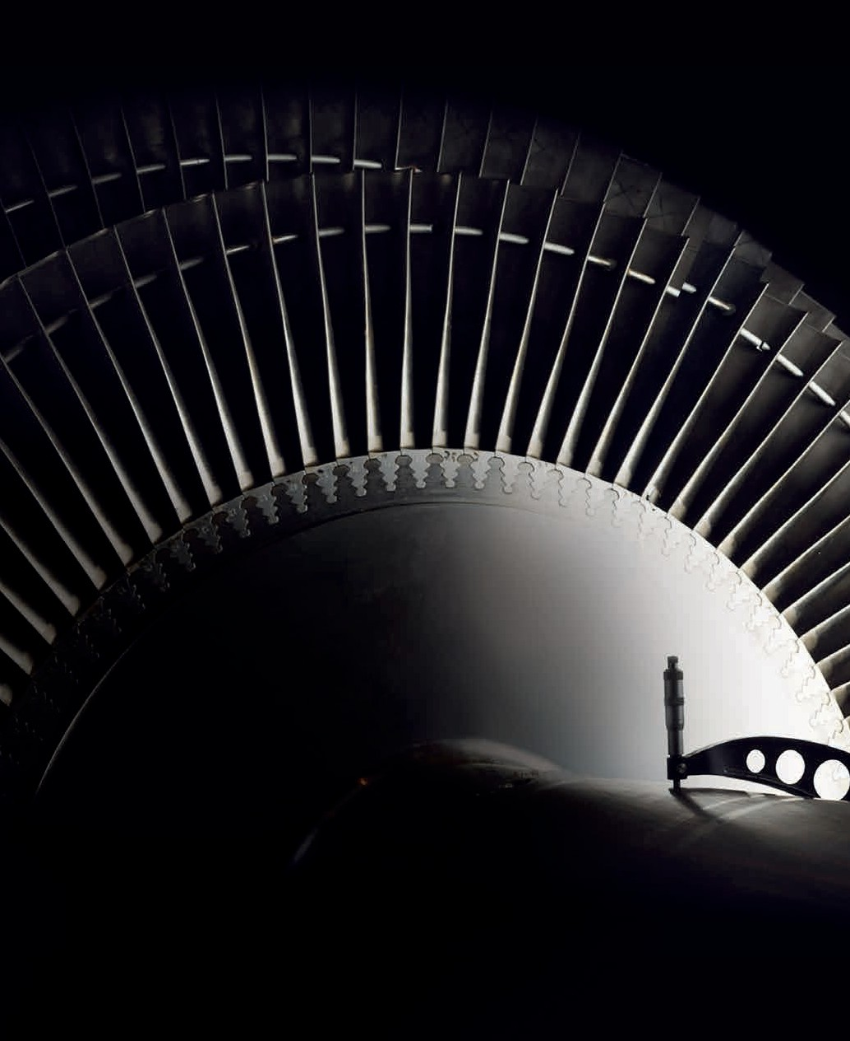



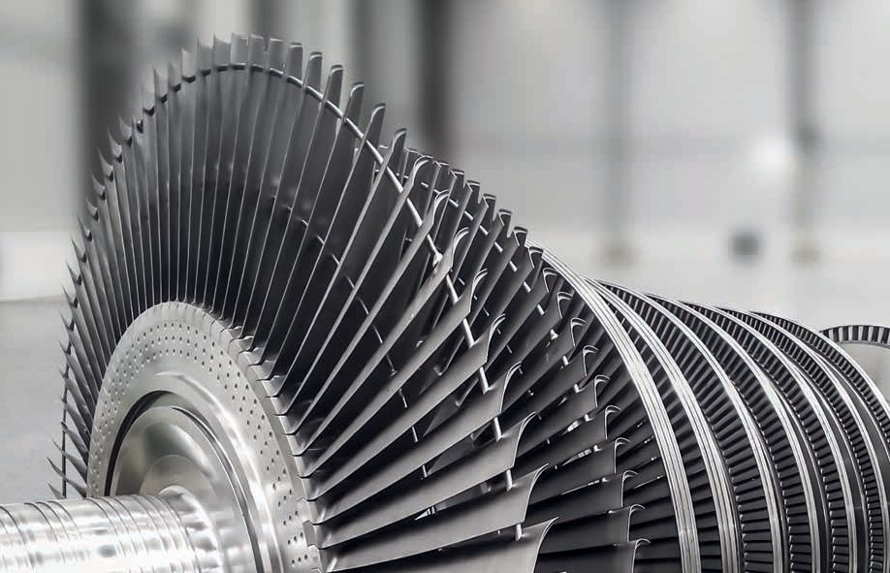

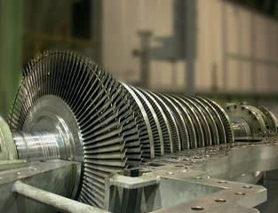



SRI JYOTHI ENGINEERING SERVICES is a leading Indian company specializing in high-capacity production and the Energy sector. With 25 years of experience, we offer innovative design and quality engineering solutions to enhance production capacity, streamline processes, and reduce costs. Known for exceptional customer service, technical expertise, and reliability, our vision is to be the most trusted specialist in Erection, Commissioning, Maintenance, and Manufacturing & Supply of spares.

**Services**

SRI JYOTHI ENGINEERING SERVICES offers a comprehensive range of engineering solutions, including reverse engineering, erection, commissioning, maintenance, troubleshooting, and major overhauling services. Our expertise extends to 3D scanning, spares manufacturing, repair, reconditioning, refurbishment, energy-saving consultancy, EDM, spark erosion, and dynamic balancing. With over 25 years of experience, we support industries like power, cement, paper, sugar, metal, fertilizers, and refineries. Our team ensures improved efficiencies, reduced downtime, competitive pricing, and enhanced performance, delivering high-quality, innovative mechanical engineering solutions tailored to meet your specific needs.

**Equipment**

### ****Engineering Solutions by SRI JYOTHI ENGINEERING SERVICES****

At **SRI JYOTHI ENGINEERING SERVICES**, we specialize in providing expert engineering solutions for a wide range of industrial equipment, ensuring optimal performance, reliability, and efficiency. Our key areas of expertise include:

1. **Steam Turbines & Boiler Feed Pumps**
   * Comprehensive support for **steam turbines, TD BFP, and MD BFP**, ensuring reliable operation of boiler feed pumps.
2. **Condensate Extraction & Vacuum Systems**
   * Maintenance and optimization of **CEPs (Condensate Extraction Pumps) and condenser vacuum pumps** to enhance condenser efficiency.
3. **Cooling Water & Vertical Turbine Pumps**
   * Performance optimization of **cooling water pumps and vertical turbine pumps** to improve heat dissipation and operational efficiency.
4. **Heat Exchangers & Thermal Management**
   * Expertise in **heaters, condensers, coolers, and compressors**, ensuring efficient thermal management and smooth operation.
5. **Industrial Fans & Air Preheaters (APH)**
   * Maintenance of **ID, FD, PA, and SA fans** to ensure optimal airflow in industrial processes.
   * Optimization of **air preheaters (APH)** for improved energy efficiency.
6. **ESP & AHP Systems**
   * Specialized support for **ESP (Electrostatic Precipitators) and AHP (Ash Handling Plant)** to ensure effective particulate removal and ash handling.
7. **Coal Handling Plant (CHP) Equipment**
   * Maintenance and efficiency enhancement of **CHP equipment**, ensuring smooth and reliable operation.

Our **experienced team** is committed to delivering **tailored solutions** that:  
✔ Minimize downtime  
✔ Improve efficiency  
✔ Extend the lifespan of critical equipment

We strive to provide top-quality engineering solutions to maximize operational reliability across industries.

**Services:**

At **SRI JYOTHI ENGINEERING SERVICES**, we provide a wide range of expert engineering solutions tailored to your needs. Here’s what we offer:

1. **Engineering Services**: Design, analysis, implementation, and optimization for enhanced equipment performance and reliability.
2. **Reverse Engineering**: Detailed insights to replicate and improve existing components and systems.
3. **Erection, Commissioning, Maintenance, Troubleshooting, and Overhauling**: End-to-end support for industrial equipment installation and upkeep.
4. **3D Scanning**: Precise scanning for accurate measurements and digital modeling.
5. **Spares Manufacturing**: High-quality, durable spares to keep your equipment running efficiently.
6. **Repair, Reconditioning, and Refurbishment**: Extending equipment life and restoring optimal performance.
7. **Energy-Saving Services**: Solutions to reduce energy consumption and operational costs.
8. **EDM / Spark Machining**: Precision machining for complex shapes and fine details.
9. **Bend Removal**: Correcting deformities in equipment shafts and rotors for reliable performance.
10. **Dynamic Balancing**: Smooth operation of rotating equipment by reducing vibration and wear.

Our services are designed to enhance **efficiency, reliability, and performance**, ensuring your operations run seamlessly.



[www.srijyothiengineeringservices.com](http://www.srijyothiengineeringservices.com)

Hyderabad, Vizayawada

[techno-commercial@srijyothiengineeringservices.com](mailto:techno-commercial@srijyothiengineeringservices.com)

[sjes331@gmail.com](mailto:sjes331@gmail.com), +917722944331, +919630311331